ProJson
JSON Generation with References
Advanced Programming - Project 2025/2026

Problem
JSON is the standard for exchanging data over the Web. The format consists of a tree, a recursive data structure resembling the Composite Pattern. However, when there is a need to encode graph-like structures, where nodes refer to other nodes, one has to resort to artifices. A typical solution is to label JSON objects with UUIDs, which are referred to as strings in the property values of other JSON objects.

Example of JSON using UUIDs
Consider the following example, where we have tasks holding a description, a deadline, and depending on other tasks (dependencies). In the instantiation example, we find three tasks, two of which are independent (T1 and T2), while the other (T3) depends on the first two. In memory, the object representing T3 has references to the objects representing T1 and T2.

class Task(
val description: String,
val deadline: Date?,
val dependencies: List<Task>
)
data class Date(
val day: Int,
val month: Int,
val year: Int
)
val t1 = Task("T1", Date(30,2,2026), emptyList())  val t2 = Task("T2", Date(31,4,2026), emptyList())  val t3 = Task("T3", null, listOf(t1, t2))  val all = listOf(t1, t2, t3) | T1  T2  T3

The following JSON presents a possible way of encoding the list of tasks in memory (all) shown above. Objects have an automatic property holding a UUID ($id), which is not present in the code. References to objects are translated into a special JSON object with a string property ($ref) that holds UUIDs to the referenced objects, rather than serializing the actual object. Notice that objects of the data class representing date values have no $id property, and are serialized normally (because they are meant to represent values). Notice also that each JSON object has a property indicating the object's class ($type).
JSON with references
[
{
"$id": "9e2e6c64-3236-45b7-8b8a-11271c69e4df",
"$type": "Task",
"description": "T1",
"deadline": {
"$type": "Date",
"day": 30,
"month": 2,
"year": 2026
},
"dependencies": []
},
{
"$id": "11fb194e-b75c-4f73-9c10-65df91b81352",
"$type": "Task",
"description": "T2",
"deadline": {
"$type": "Date",
"day": 31,
"month": 4,
"year": 2026
},
"dependencies": []
},
{
"$id": "d388f116-826f-4751-bdad-fb8cc152b968",
"$type": "Task",
"description": "T3",
"deadline": null,
"dependencies": [
{ "$ref": "9e2e6c64-3236-45b7-8b8a-11271c69e4df" },
{ "$ref": "11fb194e-b75c-4f73-9c10-65df91b81352" }
]
}
]

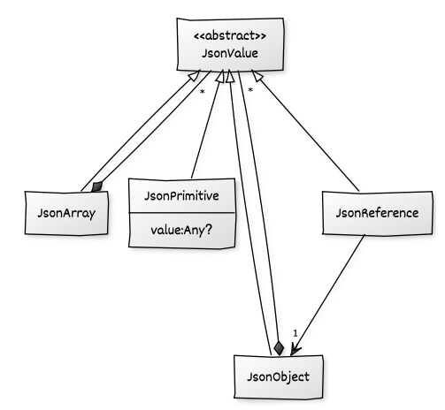
Goals
The objective is to develop a Kotlin library to generate JSON in the presented form, making the object reference management (UUIDs) transparent in the API. This implies that the client code of the library does not deal with UUIDs.

- No external libraries should be used.
- All the main functionality should be covered with test cases.
- Special care should be given to the API and documentation.

Phase 1: Standard JSON
This phase deals with the in-memory model of JSON documents and their serialization into the textual format. The library model should include two main classes for client code to create JSON objects and arrays. The library should allow these to be instantiated through reflection. Additionally, the notion of JSON reference (to a JSON object) should be part of the library model.

JSON Objects
Given any object in memory, it should be possible to generate a JSON object. If a map is passed, the JSON object should have no $type property. If a collection is passed, a JSON array is generated instead (see next).
Example | Output
val d = Date(31, 4, 2026)  val json = ProJson().toJson(d) as JsonObject  json.setProperty("year", 2027)  println(json) | {  $type: "Date",  day: 31,  month: 4,  year: 2027  }

JSON Arrays
Given a collection in memory, it should be possible to generate a JSON array.
Example | Output
val list = listOf("a", null, "b")  val json = ProJson().toJson(list) as JsonArray  json.add("c")  println(json) | ["a", null, "b", "c"]

JSON manipulation
Upon instantiation, the JSON should be able to be manipulated in memory, both for reading and writing (as illustrated in some examples). Special care should be taken to ensure that no invalid JSON is constructed. Provide an API that allows the JSON documents to be modified with respect to deleting, adding, or modifying elements, as well as a facility for traversing the tree.

Textual format
As illustrated in the previous examples (toString), the end goal is to obtain the textual JSON from the models. The priority is to generate valid JSON text, while obtaining a pretty-print (formatted with tabs, etc.) is optional.

Phase 2: References and Customization
Once the standard JSON functionality is achieved on Phase 1, this phase addresses the JSON references (as explained initially) and other forms of customizing the JSON generation.

JSON References
By annotating class properties, we can instruct the JSON generation to use references instead of the regular objects.
Example | Output
class Task(  val description: String,  val deadline: Date?,  @Reference  val dependencies: List<Task>  )  val t1 = Task("T1", Date(30,2,2026), emptyList())  val t2 = Task("T2", Date(31,4,2026), emptyList())  val t3 = Task("T3", null, listOf(t1, t2)  val all = listOf(t1, t2, t3)  val json = ProJson().toJson(all) as JsonArray  println(json) | (see initial JSON with references example)

JSON Object Properties
Using annotations, consider the possibility of customizing JSON object property identifiers, as well as ignoring class fields when generating JSON.

Example | Output
class Task(  @JsonProperty("desc")  val description: String,  @JsonIgnore  val deadline: Date?,  @JsonProperty("deps")  val dependencies: List<Task>  )  val t = Task("T1", Date(30,2,2026), emptyList())  val json = ProJson().toJson(t) as JsonObject  println(json) | {  $type: "Task",  desc: "T1",  deps: []  }

Develop a plugin mechanism that allows objects of a class to be serialized as strings in JSON. In the following example, the Date objects have a custom serialization format.

Example | Output (according to DateAsText)
@JsonString(DateAsText::class)  data class Date(  val day: Int,  val month: Int,  val year: Int  )  val d1 = Date(30, 2, 2026)  val d2 = Date(31, 4, 2026)  val json = ProJson().toJson(listOf(d1, d2)) as JsonArray  println(json) | [  "30/02/2026",  "31/04/2026"  ]

Phase 3: Documentation and Publishing
To finalize the project:
- Document your API with Javadoc-style comments.
- Publish the library on GitHub, with a release (JAR).
- The project README.md should contain a detailed tutorial about how to use the library.

